Robert Lynch

Professor Labouseur

Database Systems – CMPT 308 114

3 November 2016

Lab 7

1. Part 1
   1. This is a good collection, but it needs to be better organized. For example, the primary key in his collection is PackageID, but there are multiple rows that have the same PackageID, not making it a good primary key.
   2. 1NF

|  |  |  |  |
| --- | --- | --- | --- |
| **PackageID** | **TagNumber** | **InstallDate** | **SoftwareCostUSD** |
| AC01 | 32808 | 09-13-2005 | 754.95 |
| DB32 | 32808 | 12-03-2005 | 380.00 |
| DB32 | 37691 | 06-15-2005 | 380.00 |
| DB33 | 57772 | 05-27-2005 | 412.77 |
| WP08 | 32808 | 01-12-2006 | 185.00 |
| WP08 | 37691 | 06-15-2005 | 227.50 |
| WP08 | 57222 | 05-27-2005 | 170.24 |
| WP09 | 59836 | 10-30-2005 | 35.00 |
| WP09 | 77740 | 05-27-2005 | 35.00 |

* 1. The primary key is PackageID, but it is then also sorted by TagNumber. For example, PackageID can identify more than one computer, so the TagNumber then identifies the specific computer.

1. Part 2

|  |  |  |  |  |  |
| --- | --- | --- | --- | --- | --- |
| **PackageName** | **CompModel** | **PackageID** | **TagNumber** | **InstallDate** | **SoftwareCostUSD** |
| Spotify | IBM | AC01 | 32808 | 09-13-2005 | 754.95 |
| Chrome | IBM | DB32 | 32808 | 12-03-2005 | 380.00 |
| Chrome | Apple | DB32 | 37691 | 06-15-2005 | 380.00 |
| Firefox | Microsoft | DB33 | 57772 | 05-27-2005 | 412.77 |
| MS Word | IBM | WP08 | 32808 | 01-12-2006 | 185.00 |
| MS Word | Apple | WP08 | 37691 | 06-15-2005 | 227.50 |
| MS Word | HP | WP08 | 57222 | 05-27-2005 | 170.24 |
| MS Excel | Dell | WP09 | 59836 | 10-30-2005 | 35.00 |
| MS Excel | Lenovo | WP09 | 77740 | 05-27-2005 | 35.00 |

* 1. PackageID, TagNumber 🡪 PackageName, CompModel, InstallDate, SoftwareCostUSD

PackageID 🡪 PackageName

TagNumber 🡪 CompModel

* 1. This is not in 3NF because it does not make 2NF. In order for it to be in 2NF the tables need one primary key, this does have two primary keys (PackageID & TagNumber), making it a partial key dependency).

1. Part 3

Software

|  |  |
| --- | --- |
| **PackageName** | **PackageID** |
| Spotify | AC01 |
| Chrome | DB32 |
| Firefox | DB33 |
| MS Word | WP08 |
| MS Excel | WP09 |

Computer

|  |  |
| --- | --- |
| **CompModel** | **TagNumber** |
| IBM | 32808 |
| Apple | 37691 |
| Microsoft | 57772 |
| HP | 57222 |
| Dell | 59836 |
| Lenovo | 77740 |

Installation

|  |  |  |  |
| --- | --- | --- | --- |
| **PackageID** | **TagNumber** | **InstallDate** | **SoftwareCostUSD** |
| AC01 | 32808 | 09-13-2005 | 754.95 |
| DB32 | 32808 | 12-03-2005 | 380.00 |
| DB32 | 37691 | 06-15-2005 | 380.00 |
| DB33 | 57772 | 05-27-2005 | 412.77 |
| WP08 | 32808 | 01-12-2006 | 185.00 |
| WP08 | 37691 | 06-15-2005 | 227.50 |
| WP08 | 57222 | 05-27-2005 | 170.24 |
| WP09 | 59836 | 10-30-2005 | 35.00 |
| WP09 | 77740 | 05-27-2005 | 35.00 |

* 1. Primary Keys –

Software: PackageName

Computer: CompModel

Installation: PackageID, TagNumber

* 1. Functional Dependencies

Software: PackageName 🡪 PackageID

Computer: CompModel 🡪 TagNumber

Installation: PackageID, TagNumber 🡪 InstallDate, SoftwareCostUSD

* 1. The new tables are in 3NF because they now do not have partial key dependencies. The data is atomic and there is no duplicate data. There is also now no multiple key dependancies.
  2. 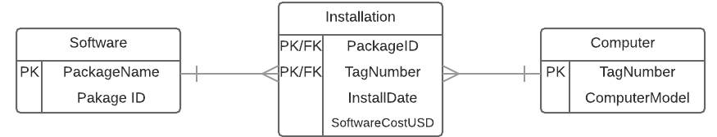ER Diagram